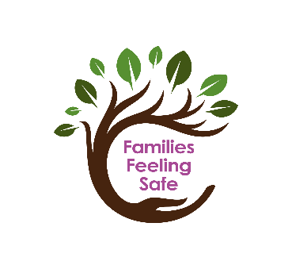
PROTECTIVE BEHAVIOURS
CN26006 – Level 1 (Foundation) Training
Online
27 January & 3 February 2027, 9.30am – 4.30pm

This is an online Level 1 (Foundation) 2-Day course provided by Families Feeling Safe Protective Behaviours Services on Wednesdays 27th January and 3rd February 2027, 9.30am – 4.30pm. The cost for the 2 Day course is £275.00 + VAT (£330). The course fee includes all course materials, a Level 1 book and certificate. This is an open access course for anyone wishing to learn about Protective Behaviours.

Day 1: To explore the content of The Protective Behaviours Process
Day 2: To explore the application of The Protective Behaviours Process

Families Feeling Safe, Protective Behaviours Services provide Protective Behaviours (PBs) training courses, PBs programmes and workshops for professionals and families. We work in partnership with a range of organisations to build capacity and the sustainability of Protective Behaviours practice. As an early intervention approach, Protective Behaviours can improve the emotional wellbeing of children, families and individuals of all ages and help them build the skills they need to keep themselves and others feeling safe while reducing the need for more specialist help. This course is also intended to support staff by enhancing their own emotional wellbeing, with skills and strategies to keep themselves feeling safe and with increased tools and ideas to use in their practice.
About Protective Behaviours
Protective Behaviours (PBs) is a practical and down-to-earth approach to personal safety, resilience and wellbeing that encourages self-empowerment and brings with it the skills to avoid becoming victimised. This is achieved by helping people recognise and trust their feelings (Early Warning Signs), build safe networks of support, develop strategies for problem-solving, recognise the influence of Unwritten Rules and beliefs, improve resilience and have increased awareness of how language can enhance communication and relationships to enable children, young people and adults to feel safe. The Protective Behaviours Process encourages an adventurous approach to life which satisfies the need for fun and excitement without violence and fear and is relevant to people of all ages and abilities including staff.

Dates | Venue | Times
Wednesdays 27th January & 3rd February 2027 | Online via Zoom | 9.30am – 4.30pm

PROTECTIVE BEHAVIOURS ONLINE LEVEL 1 (FOUNDATION) TRAINING - BOOKING
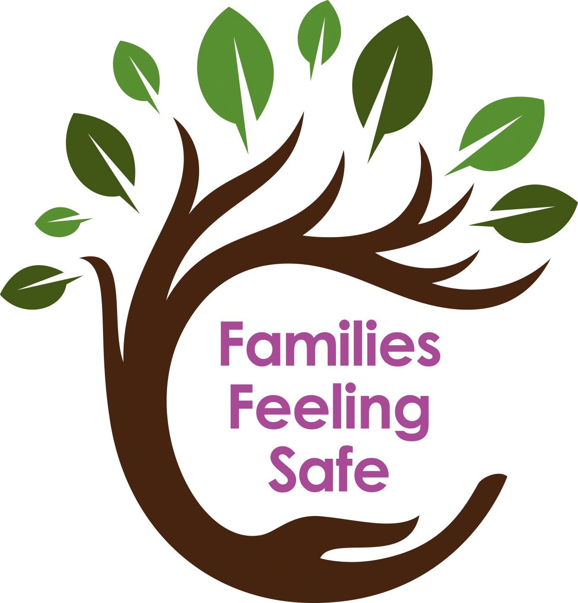
CN26006
Online – Wednesdays 27 January & 3 February 2027, 9.30am – 4.30pm
Please provide your details below

Your name
Job role
Place of work
Please choose full postal address to send your course book (work or home?) *Addresses are not saved on our systems

Work Tel. No.
Mobile No.
Email address for zoom link
Do you have any particular needs we may need to know about?

Please tell us how you think Protective Behaviours could benefit you and your work with children /parents/carers:

To book your place we need the following information: (*mandatory). Failure to provide this information will result in us having to return the form to you.
Payment – please provide details for invoicing
The cost per place is £275.00 + VAT (£330)
Purchase Order Number (if applicable):
*Local authority staff only: In order to confirm your booking, we need a purchase order number please.
* Contact Name for invoicing: | Position:
* E-mail: (required for invoicing)

Address for invoice (if different):

Postcode: | Telephone:
*Manager’s Signature: (written or typed) | Your signature confirms that you have read and agreed to our Terms and Conditions of booking. Please note our cancellation terms in particular.

Please return this form by e-mail to: admin@familiesfeelingsafe.co.uk
Families Feeling Safe
Protective Behaviour Courses

Terms and Conditions

Effective from January 1st 2020.
“FFSL” means Families Feeling Safe Ltd.
“candidate” means the person who is booked to attend the course.
“establishment” means the school or organisation who makes the booking.

Booking
- Important note: Acceptance of your booking brings into existence a legally binding contract between us on these terms and conditions.
- Before booking onto the course, please ensure you have read the course content to ensure the course meets your training needs and that you are able to meet the pre-requisites where these are stated.
- It is best to return the booking form via email to admin@familiesfeelingsafe.co.uk. However, if sent by post please note that the FFSL office is unstaffed a lot of the time and this delay may result in a place not getting booked in time.
- By attending this course you are consenting to be added to our database where we keep a record of attendance. We also use this database for sending you further information about our Protective Behaviours services. Your information will not be shared with a third party. Please see our Privacy Policy on our website.
Purchase Orders
- Applications from Herts County Council MUST include a PO number on the course application form.
Invoicing and payment
- Course fees include tuition on the day/days, all relevant course materials
- FFSL will send an invoice by email to the manager of the establishment stated on the booking form at the same time as we send the confirmation of booking.
- Invoices must be paid within 30 days of the invoice date or prior to the course starting, whichever is sooner.
- Payment must be made by cheque or BACS to the account shown on the invoice. Please write the invoice number on the back of the cheque or include it in your payment reference on BACS.
- All course fees include VAT at the current rate.

Course attendance and certification
- Candidates will receive joining instructions via the email address shown on the booking form.
- It is the responsibility of the individual completing the booking form to ensure that the joining instructions are received by the course candidate.
- If joining instructions are not received from FFSL, it is the responsibility of the individual who completed the booking form to contact FFSL to arrange for them to be reissued.
- All candidates who complete the training courses will be issued with a Certificate which will include a course number. This number will be required to access further course progression.
- In the event of a certificate being lost a charge of £15 + VAT will be made for a replacement.
- Candidates who do not attend all sessions of the Level 1 training on the booked course may, with the agreement of FFSL, attend the sessions on a future course, provided a place is available. A Certificate will be given to the candidate when all sessions are completed.
- In order to complete and receive a Certificate on the Level 2 or Facilitator training courses, all days must be attended on the booked course. It is not possible to complete the training by attending missing days on a future course.
Cancellations, substitutions and amendments
- Failure to attend the course will result in the full cost being incurred.
- Course candidates may be substituted for another candidate from the same establishment without charge. Changes must be notified to admin@familiesfeelingsafe.co.uk as soon as possible.
- Cancellation of bookings will result in the following refunds:
Calendar days notice before the start of the course | Refund applicable
29 calendar days or more | Full refund  minus £25.00 + VAT administration fee
Between 15 and 28 calendar days (inclusive) | 50% refund  minus a £25.00 + VAT administration fee. Alternatively a substitution will be accepted.
Between 1 and 14 calendar days (inclusive) | No refund will be given but a substitution will be accepted
Failure to attend | Treated as late cancellation and no refund will be given

- In the event of there being insufficient numbers booked onto a course FFSL reserves the right to cancel or postpone the course.
- In the event of cancellation of a course by FFSL, we will endeavour to inform all participants a week before the course is due to take place, although please be aware that this is not always possible. All course fees will be reimbursed in full, or the payment will be transferred to a future course with the agreement of the establishment.
- FFSL shall not accept liability for any consequential loss and shall have no liability to reimburse any other costs that may have been incurred.

